GLIMS_Line

GLIMS_Line

Group 3

Book Gamut

Final Project Report

GLIMS_Line

GLIMS_Line

#1 Thodimela

#3 Kolli

#4 Pallapothu

#15 Kotha

#17 Gorijala

#28 Kanigiri

Contents

[Contents 2](#_Toc443092562)

[1 Overview 3](#_Toc443092564)

[2 Special Features 3](#_Toc443092577)

[3 Lessons Learned 7](#_Toc443092578)

[4 Flow Chart 8](#_Toc443092577)

[5 Scope of the project 8](#_Toc443092577)

[6 Group Diary and Work Completed 8](#_Toc443092577)

1. Overview

This site is a Best online book store and book finder that provides facilities to buy, search new or old books of all categories online. There are two logins, The User login and The Admin login to buy or manage books online. Admin will have rights to add or modify the books and can also delete the book when required.

User will be able to select a book and add it to the cart to own it.

1. Special Features

**Designing the database:**

The database of the project is designed to implement the Registration page, Login page, Home page, Home Detail page and Management page.

1. **User Registration page:**

The Registration page has User Name, Password, Confirm Password, Email, First Name, Last Name, Address, Postal code.

1. **User Login page:**

The User Login page has User Name and password and also the option to reset the password.

1. **Home page:**

Home page has collection of books for the user to select among. A click on the particular item will help us to choose the book and add it to cart.

1. **User Profile:**

Logged in user will be able to view and update his profile. Also **change** **password** option is provided for the user to change his password.

1. **Management page:**

Management page will help you save the admin details and also allows us to give access to the registered users.

**Designing pages:**

1. **User Registration page:**

The Registration page has text boxes to enter the details of the user and a Sign Up button.

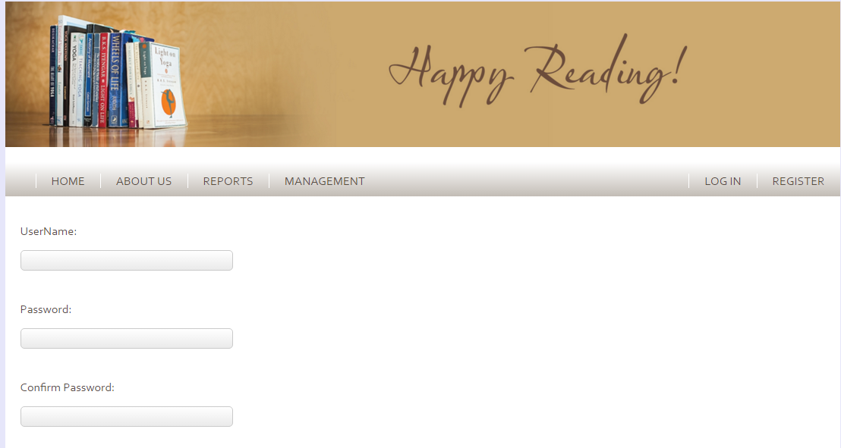



1. **User Login page:**

The User Login page has text boxes to enter the User Name and password and also the Sign In and ForgotPwd buttons.

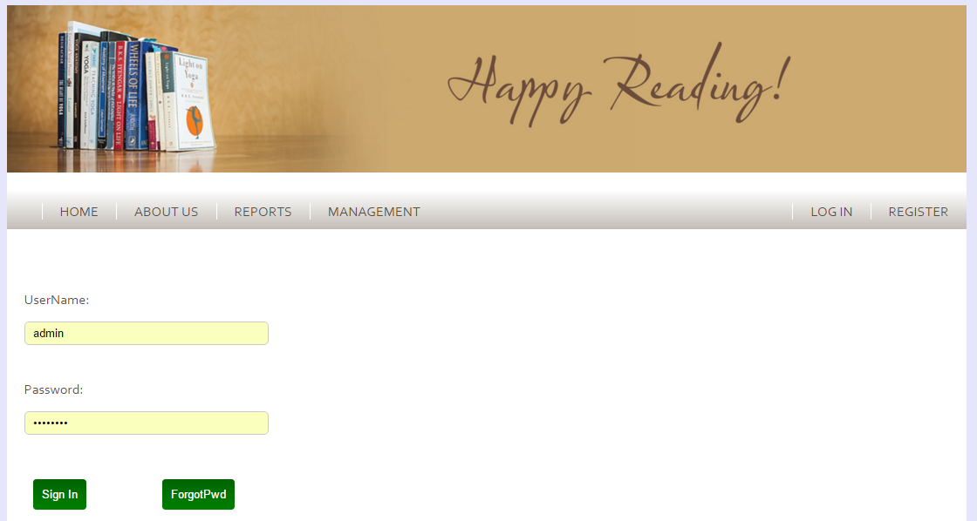

1. **Home page:**

Home page has collection of books for the user to select among. It has icons for each entry of the book and a click on that will navigate to the details page of the book.



1. **User Profile:**

User Profile will help you view the user details. An option to edit these details is provided.

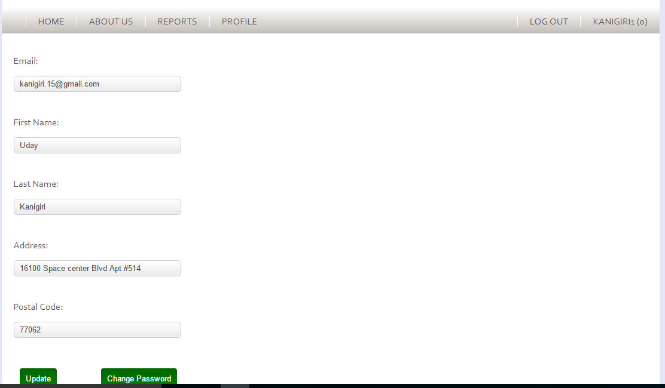

1. **Management page:**

Management page will help you save the admin details and also allows us to give access to the registered users. The entry of the books can be either edited or deleted. It has User Name and Password text boxes and a Sign in and ForgotPwd buttons.

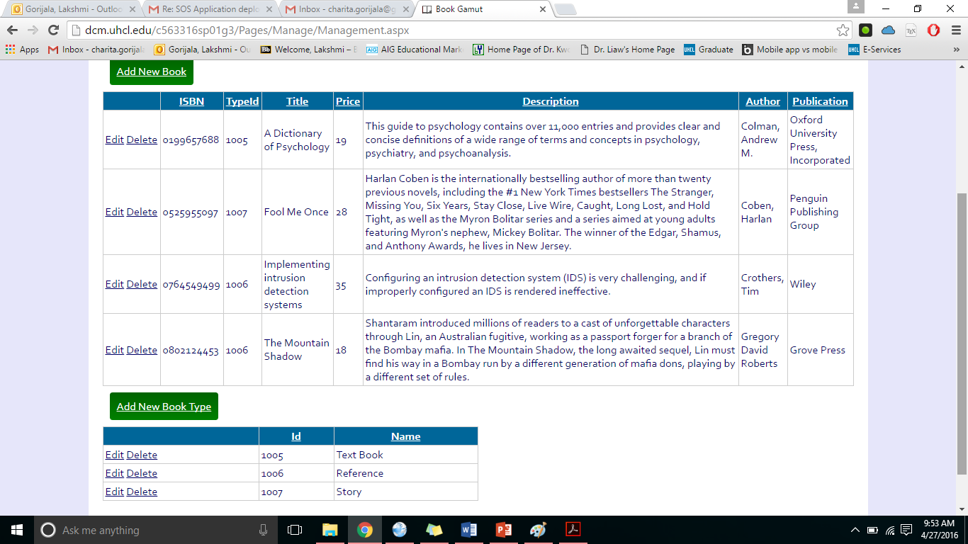

1. Lessons Learned From this project our group has learnt on how to design a web application along with the database. Going deeper, we have learnt on how to create forms for the part of an application and allow users to access the website. We have collected different user data of the customers to test the application.

From this assignment, our group has learned that conducting a group project on specific product requires understanding the audience, the different perspectives of the product, and team coordination.

1. Flow Chart

Registration

Management (Admin)

Login page

Home page

Home Details page

1. Scope of the project The scope of this project is to create an integrated website to purchase different categories of books online. This website helps in visibility of our services options. It provides features for all the customers to custom select their book categories. Also admin has the ability to manage books for the customers. The website is designed to handle the traffic of all the customers accessing the website.
2. Group Diary and Work Completed

We have divided the different tasks among our group members to come up with relevant information for the assigned tasks. The details are as follows:

* Survey about online book stores 2-10-2016.
* Set up environment on 2-17-2016.
* Define phase (Documentation) 2-17-2016.
* Design phase (Documentation) 3-23-2016.
* Development 4-13-2016.
* Deployment 4-20-2016.